**VehiclePickingBatch Model description**

This model is going to show how to pick multiple orders in a user defined batch. The default vehicle working patten is pick a modelentity and then transport it to its destination. But, in this model, we have a customized vehicle which can pick multiple modelentities before transporting to a destination.

In this model, our modelentity is order, we have a data table to create the entity and store the associated information. The table is show below.

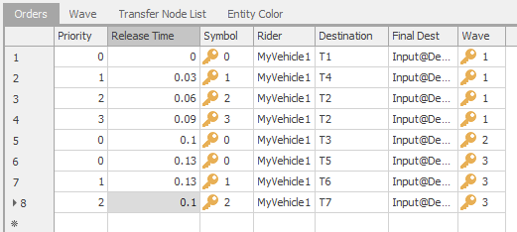

According to the above table, there are 7 columns, they are:

Priority: This is used to indicate the picking sequence in a wave(batch)

ReleaseTime: when to create the order.

Symbol: used to change the order color

Rider: the picking vehicle object

Destination: at which transfer node the picking activity occurs

FinalDest: the order destination

Wave: the batch ID

Based on this data table, when you run the model, the vehicle will first pick order 1-4 and then transport them to depot. Then, the vehicle will pick order 5 and transport it to depot. Finally, the vehicle will pick order 6-8 and send them to depot.

Also, you’ll find that order 8 is released before order 6-7. However, because in wave 3, the picking sequence is order 6-7-8, the vehicle will wait until finishing picking order 6-7.